Problem Description:

Display a frame that contains three labels. Each label displays a card, as shown in the figure below. The card image files are named 1.png, 2.png, ..., 54.png and stored in the image/card directory. All three cards are distinct and selected randomly.

The image icons used in the exercises can be obtained from [www.cs.armstrong.edu/liang/intro8e/book.zip](http://www.cs.armstrong.edu/liang/intro8e/book.zip) under the image folder (i.e., image/card/1.png)

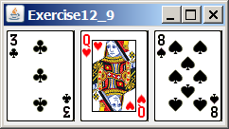

Your Task:

1. Create three JLabel and set their icons using the images.
2. Display three images from 54 image cards randomly.